Linux Task 02: Users, Groups & File Permissions
Part A: Understanding Users
1.whoami
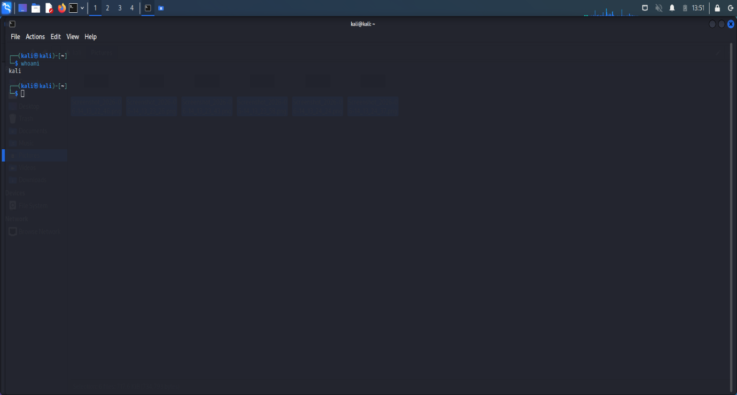
2.id
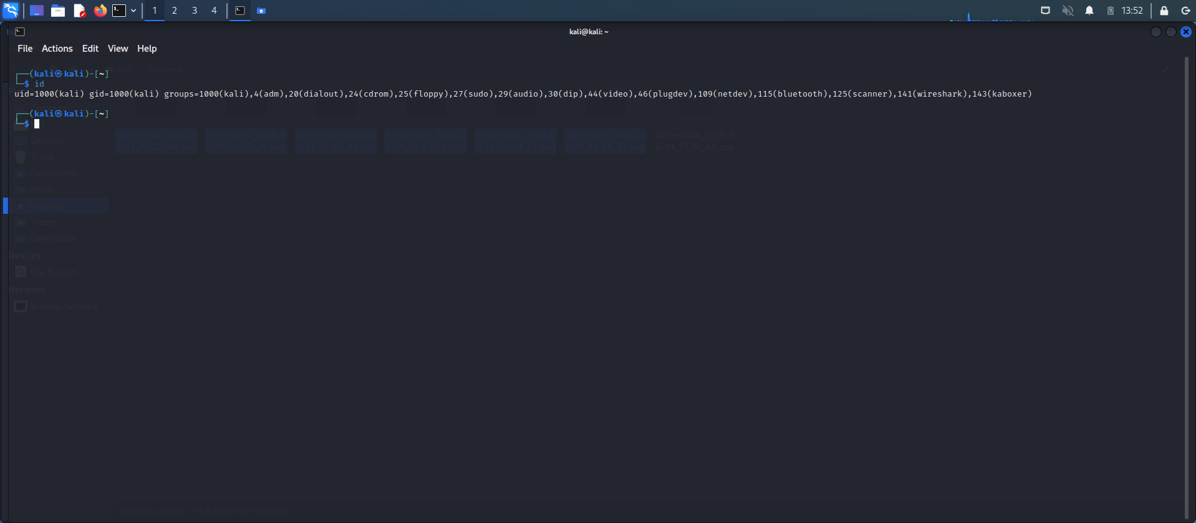

3.cat /etc/passwd
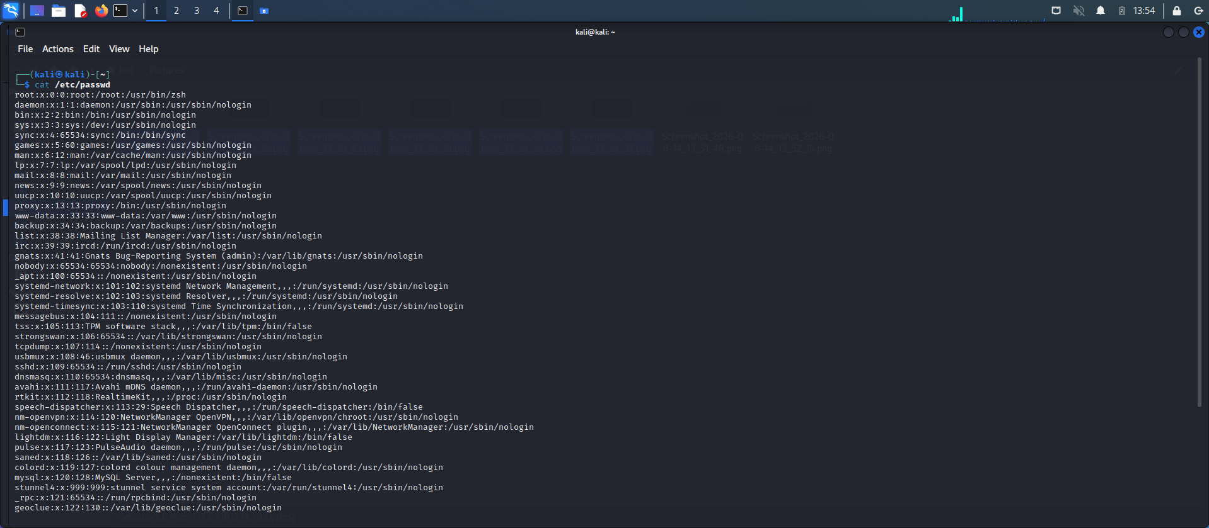
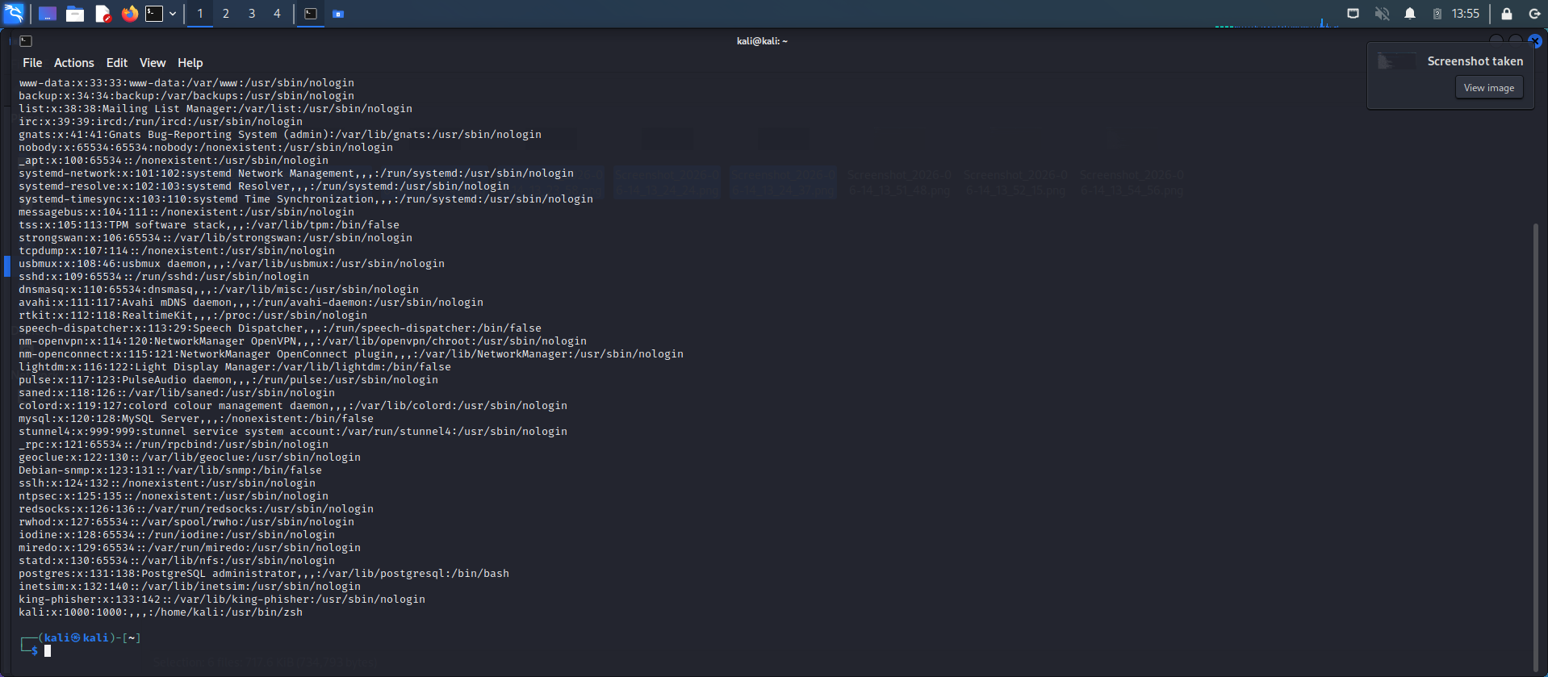

1. What is your current username?
The current user name is kali. the current username is the name of the user account that is currently logged into the Linux system. It helps the operating system identify who is using the computer and what permissions that user has.
2. What is UID?
UID (User ID) is a unique number assigned to each user in Linux. The system uses this number to identify users and manage their access to files, folders, and system resources. Every user has a different UID.
3. What is GID?
GID (Group ID) is a unique number assigned to a group in Linux. Users can belong to one or more groups. The GID helps Linux manage permissions for a group of users who need similar access to files and resources.
4. What information does /etc/passwd contain?
The /etc/passwd file contains information about all user accounts available on a Linux system. It stores details such as the username, user ID (UID), group ID (GID), home directory, and the default shell assigned to each user. This file helps the operating system keep track of user accounts and their settings.

Part B: Create Users & Groups
Commands:-
sudo groupadd
sudo useradd -m
sudo passwd
sudo usermod -aG
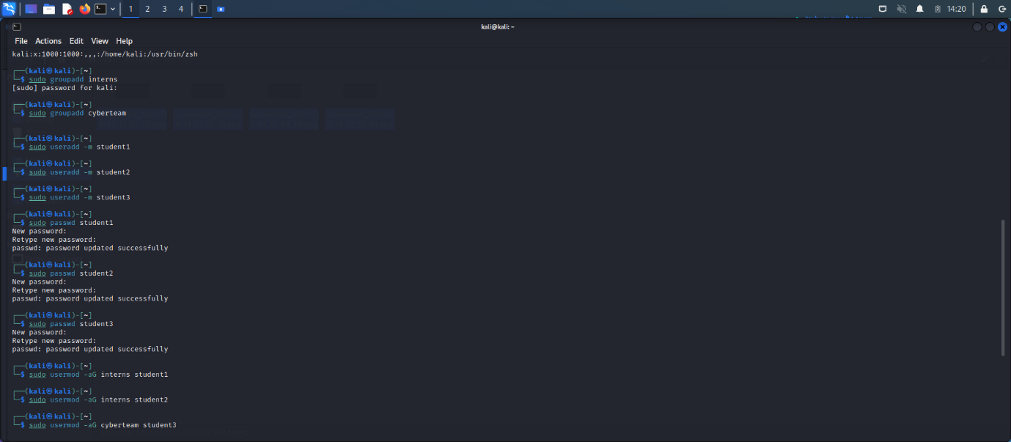
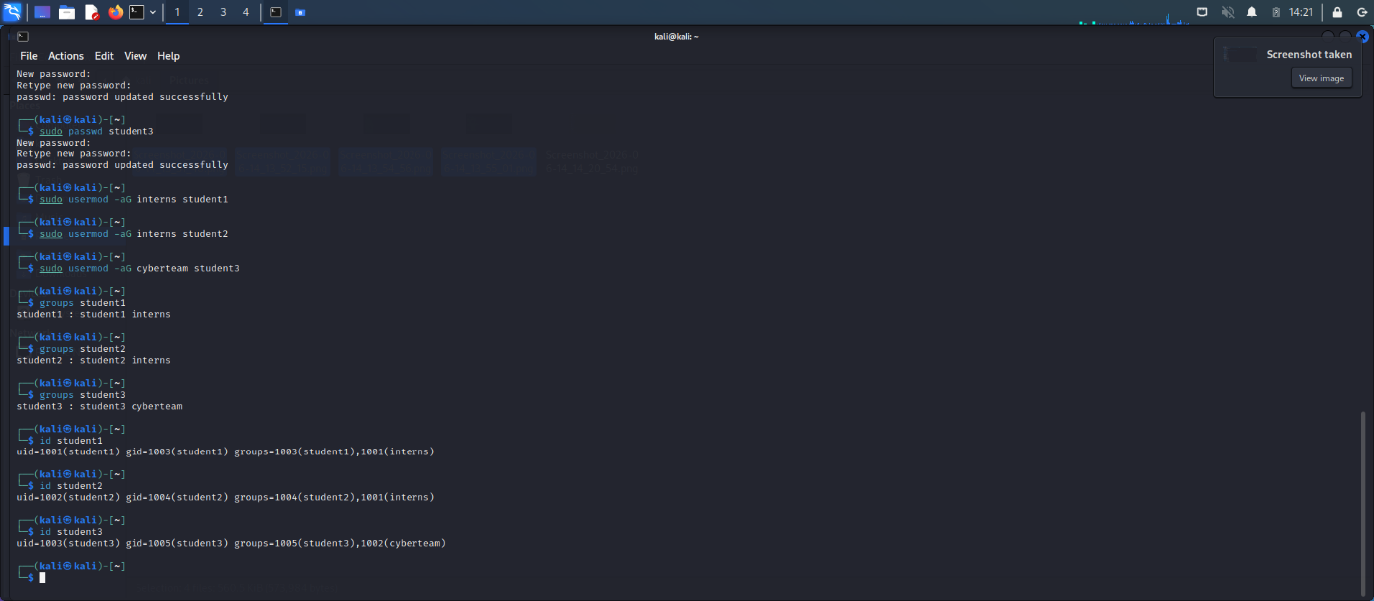

Part C: File Ownership
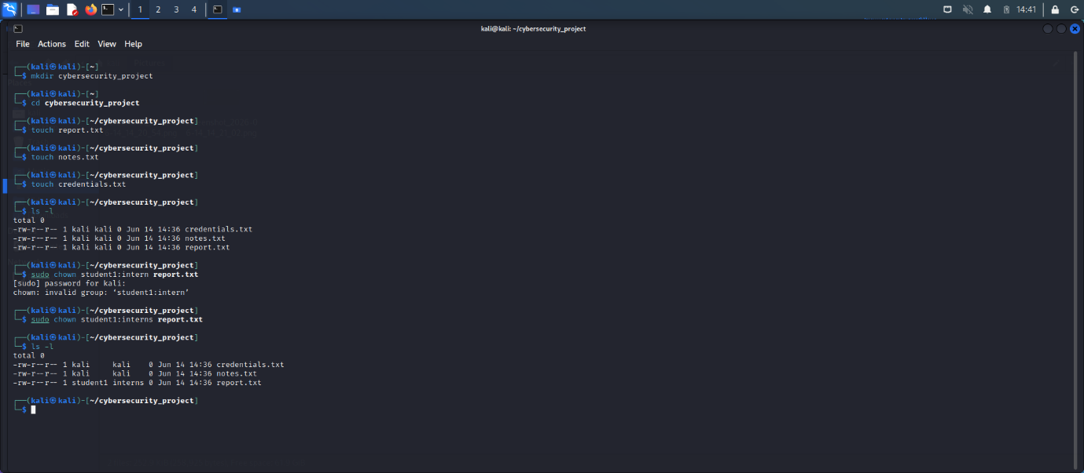
Original Owner:-kali
New Owner:-student1
Command Used:- sudo chown student1:interns report.txt
Part D: File Permissions
File Created: security_policy.txt
Permission Changes:
1. Read Only (r--r--r--)
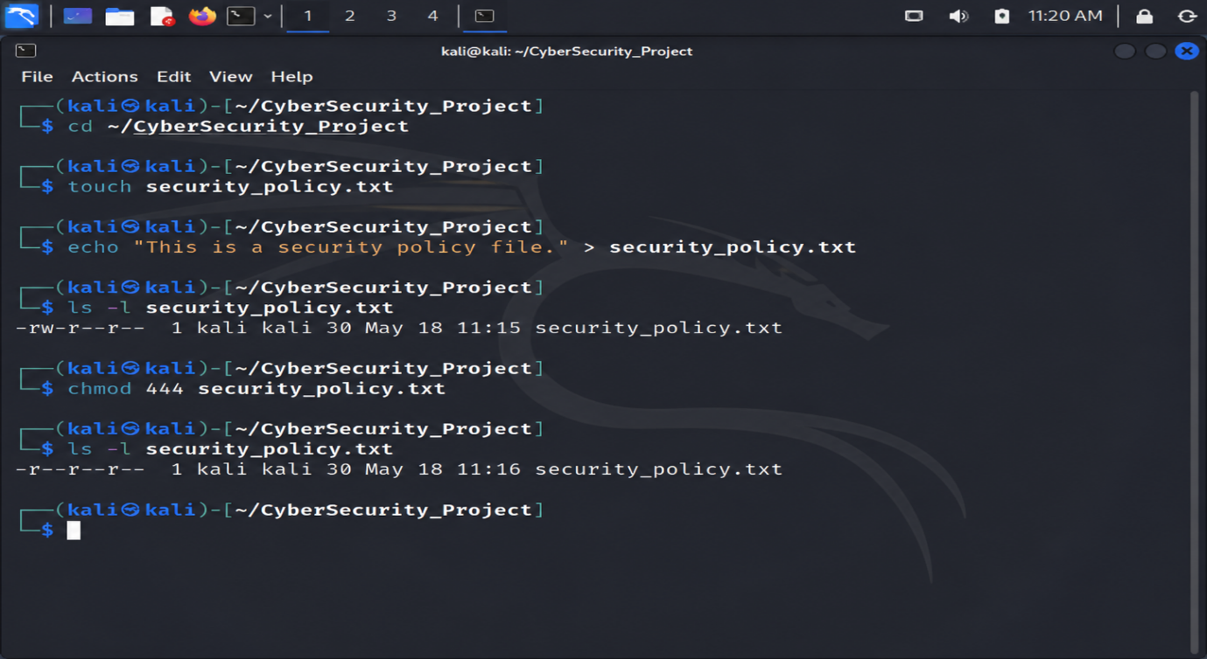
2. Read & Write (rw-rw-r--)
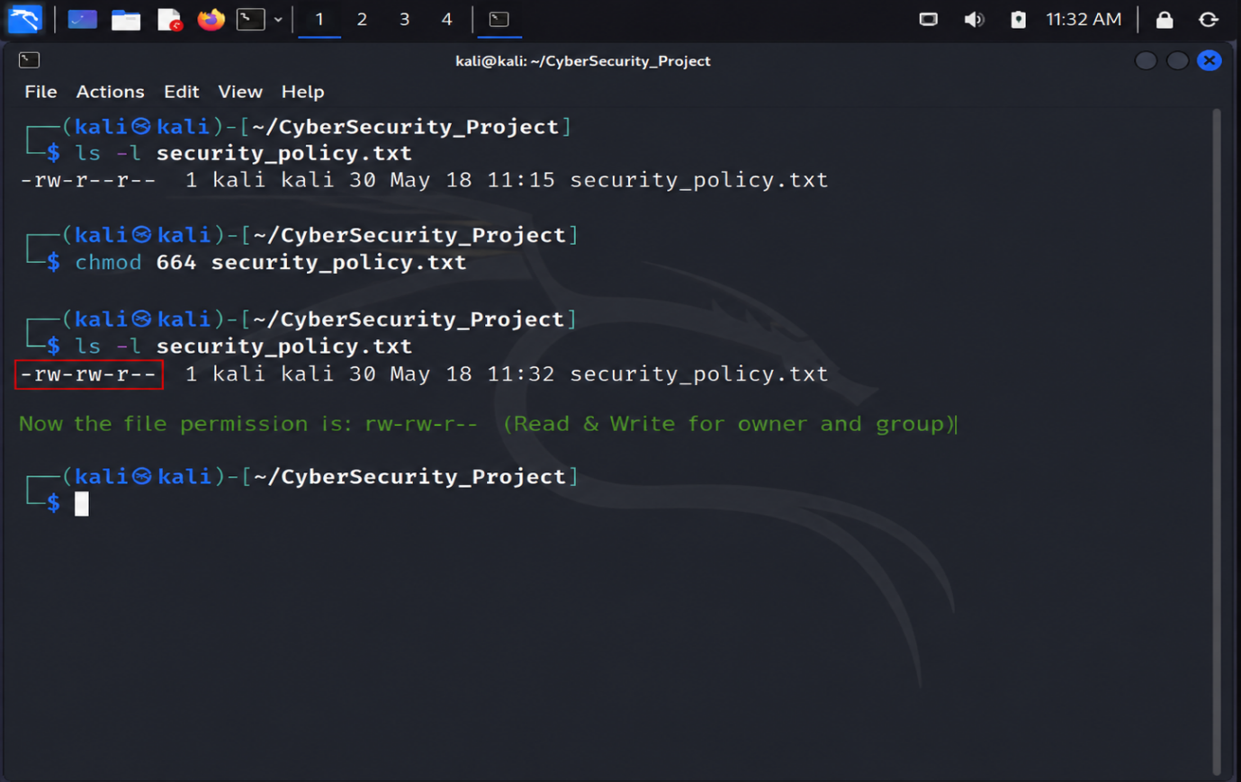
3. Full Access (rwxrwxrwx)
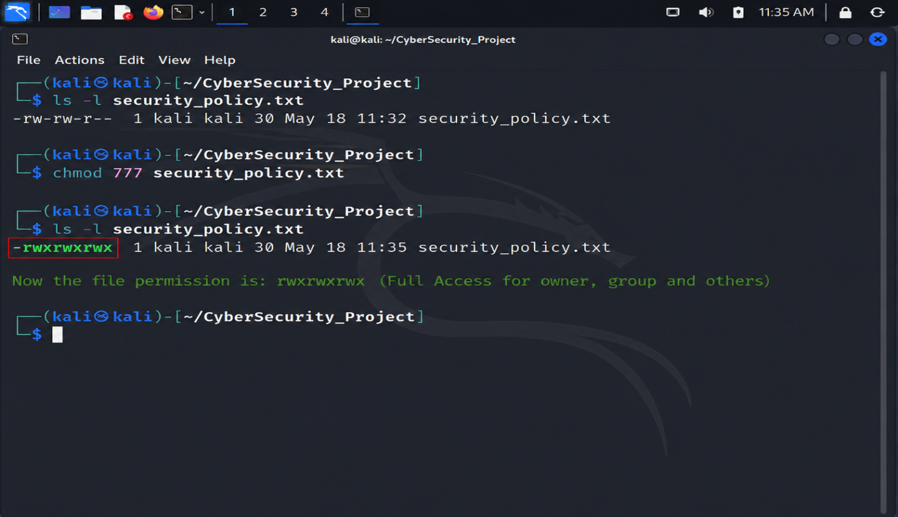

Part E: Permission Analysis
755
Owner Rights: Read, Write, Execute
Group Rights: Read, Execute
Other Rights: Read, Execute
Use Case: Website folders and application directories.
644
Owner Rights: Read, Write
Group Rights: Read
Other Rights: Read
Use Case: Normal text files and configuration files.
777
Owner Rights: Read, Write, Execute
Group Rights: Read, Write, Execute
Other Rights: Read, Write, Execute
Use Case: Generally not recommended because everyone gets full access.
600
Owner Rights: Read, Write
Group Rights: No Access
Other Rights: No Access
Use Case: Passwords, private keys, and confidential files.
700
Owner Rights: Read, Write, Execute
Group Rights: No Access
Other Rights: No Access
Use Case: Private directories and personal scripts.
Part F: Security Challenge
File - Recommended Permission - Reason
password_backup.txt - 600 - Contains sensitive password data
public_notice.txt – 644- Everyone can read it but only owner can modify system_log.txt -640 - Admin can edit, others can only view if allowed
personal_notes.txt - 600 - Personal and private information
Reasoning:
Permissions should be assigned according to the sensitivity of the data.
Part G: Linux Security Research
1. Why are file permissions important?
File permissions help protect data from unauthorized access, modification, or deletion.
2. What happens if sensitive files are given 777 permissions?
Any user can read, modify, or delete the file. This creates a serious security risk.
3. What is the Principle of Least Privilege?
Users should be given only the minimum permissions required to perform their work.
4. Why do organizations restrict user access?
Organizations restrict access to protect sensitive data, prevent misuse, and reduce security risks.

